Instructions to run Web application

Introduction:

* I have created one application of Student management in which you can post, create edit, update and delete any student details.
* It is written in C# using Visual Studio 2017.
* It has two parts
  + Server: All the functionalities are written in the server.
  + Client: Wrote one console application which is calling the functions written at the server side.
  + Testing through client and POSTMAN

Steps to run application:

* Download both packages named as server2 and client.
* Run server.sln which will open a URL page on a browser.

Now, a window like this will come

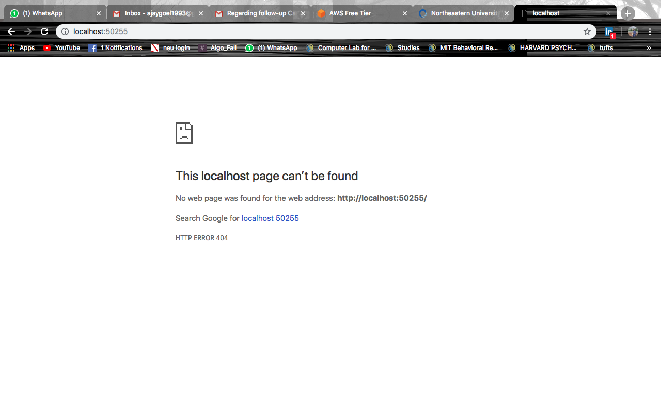

* Enter URL as : [**http://localhost:50255/api/students**](http://localhost:50255/api/students)



* Please note localhost number varies machine to machine. So, We can simply add api/students after localhost which display the test data from the text file which is forming when the server starts.
* We can use different routes to do check the details like if we want to check the particular student with id then add: <http://localhost:50255/api/students/1>
* This will show a window with the data of student having id as 1.

Testing:

* I used POSTMAN to check all the CRUD (Create, Read, Update, Delete operations), whether the operations are working or not.

Screenshot1:

GET – Getting all the data stored in my text file.



PUT – Adding one more student in the file



POST- Editing one student record by changing it’s email id.



Verification by getting the record:

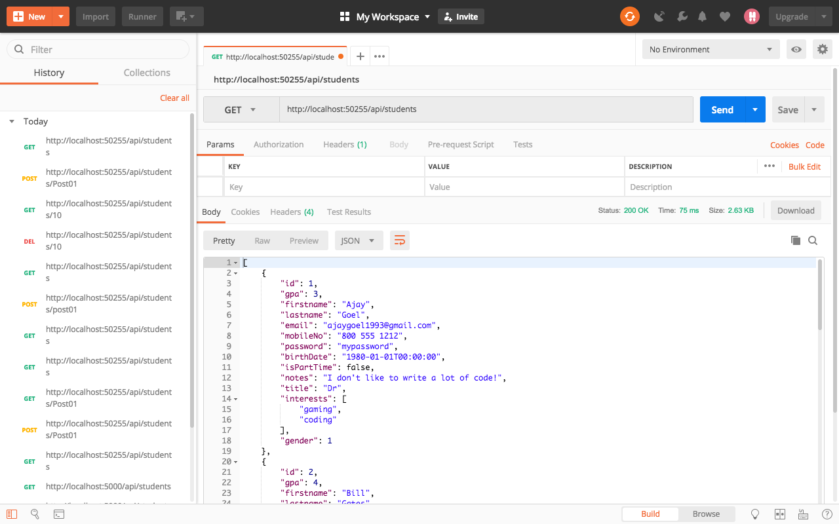

DELETE – Deleting the record having id as 10



Verification – Getting the record of id as 10



I created one client side also, we can run it by clicking on **ConsoleApp1.sln**, I just tried to get all the data, update, add and delete data at client side using async method.

**Features to improve it:**

* I will use a database instead of a text file in which data is stored in a json format.
* The database will help the system in bringing stability. We can design it according to our architecture of a school.
* Creating a MVC application at client side will give it a pretty UI and we can make a whole student management system using this.
* Additional features include:
  + Login Portal – Students, Teacher
  + Different views to submit, post assignments.
  + Announcement boards.
  + Grade boards